Chemistry Unit 1 & 2 – Assignment #1
Analytical chemistry is the branch of chemistry that deals with analysing samples to identify whether or not compounds are present in a material and – if they are present – then in what concentration. This has a large range of applications in different contexts including forensics, mining, agriculture, medical and environmental science.
There are a range of instruments which can aid in identifying substances. In this task you will learn about the following analytical methods:
- Atomic absorption spectroscopy (AAS)
- Gas chromatography-mass spectrometry (GC-MS)
(Note: Gas chromatography and mass spectrometry are two separate analytical methods, but they are often used together. Gas chromatography is used to separate substances in a mixture and then mass spectrometry is used to identify the different compounds in the mixture.)

Assignment format:
- Outside of class time you will research information about AAS and GC-MS. You will prepare a written assignment which includes some short-answer questions and extended written response (2-3 pages). The short answer questions and the extended written response will each be about a different analytical method. These components of the assignment are worth 24% of the assessment mark.

- In class, you will complete a validation test to ensure that you understand content related to AAS and GC-MS. The format of the test will be similar to other chemistry tests. It will be performed under test conditions and you will only have access to the chemistry data book. This component of the assignment is worth 76% of the assessment mark.

Suggested preparation:
Before beginning the assignment you will need to learn about the various methods. Your first step should be to read the relevant sections of your textbook.
Topic | Page | Notes
Atomic absorption spectroscopy | 127-130
Mass spectrometry | 131-132
Chromatography | 289-297 | Focus on the introduction and the GC sections
Analysing elements | 9-15

You will also need to choose which analytical method to use for the short answer questions and which to use for the extended written response. The difference between the two is that there is a higher level of research expected for the written response and you need to write about a particular application of the instrument (see suggestions on Page 3). The extended written response will also assess your ability to reference information, structure ideas and follow conventions used in scientific writing.
If you are interested in writing about a particular application, you should look up information about how that sample is analysed with either AAS or GC-MS. Most applications are only analysed using one of these methods. Make sure that there is sufficient information available before deciding on a topic – some topics will be easier to write about than others.
It is also possible to write about applications other than the ones suggested. If looking for inspiration, try searching for terms such as ‘what is atomic absorption spectroscopy used for’ or ‘applications of GC-MS’. If you are unsure about whether a particular application is okay or not then check with your teacher first.
Atomic Absorption Spectroscopy – Short Answer Questions
(Only answer these questions if your extended written response is about GC-MS)
- Explain why different elements emit and absorb characteristic wavelengths of light. (2 marks)
- Show a labelled diagram/schematic of AAS showing the main features of the instrument
(1 mark)

- Explain the role of the following components of an AAS instrument: (4 marks)
  - Hollow cathode lamp
  - Burner and nebuliser
  - Monochromator
  - Photomultiplier detector

- Explain how a calibration curve is constructed and include an example of a calibration curve. Using the graph, show how the calibration curve is used to find the concentration of an element in an unknown sample. (3 marks)

Gas Chromatography-Mass Spectrometry – Short Answer Questions
(Only answer these questions if your extended written response is about AAS)
- Show a labelled diagram/schematic of gas chromatograph instrument (1 mark)

- Describe what happens to a mixture when it is placed on a gas chromatograph and explain why the components of a mixture get separated. Include the role of the oven, column and inert gas in your answer. (3 marks)
- Show an example of a gas chromatogram and explain how this could be used to identify substances. (1 mark)

- Show a labelled diagram/schematic of a mass spectrometer (1 mark)

- Describe the processes that occur while a substance is being analysed by a mass spectrometer, including ionisation, acceleration, deflection and detection. (3 marks)
- Show how to calculate the average atomic mass of an element using a mass spectrum of its isotopes. (1 mark)

Extended Written Response:
(This question should be about the opposite method to your short-answer questions)
For your extended answer you need to write a 2-3 page assignment explaining how either GC-MS or AAS is used for a particular application. You application could be chosen from the following list or could be another application of your own choice:
Applications of AAS | Applications of GC-MS
- Analysing mercury content in fish  - Analysing the lead content of paints  - Analysing the concentration of trace elements in soils  - Analysing the mineral content of ores  - Analysing presence of heavy metals in the environment | - Identifying banned drugs in urine samples  - Identifying contaminants such as pesticides in foods  - Identifying accelerants at the scene of a potential arson  - Detecting traces of chemical explosives  - Identifying poisons in toxicological samples

Information you need to include:
- Background information about the substance that needs to be analysed and why it is important that we can analyse/identify/detect these substances.

- Information about how that sample can be analysed using either GC-MS or AAS, including:
  - How the analytical method works (e.g. how GC-MS works or how AAS works)
  - How the collected data is used to analyse your sample (e.g. calibration curves / GC-MS spectra)

Format of a written response:
Written chemistry assignments have some similarities with an English essays, but they also have clear differences. For example, a science assignment should have headings breaking up the assignment into different sections and where appropriate should include diagrams, graphs, chemical equations, calculations and tables.
Your response should include:
Section | Content
Introduction | - Describes the topic of the assignment  - Gives the minimum necessary background for the topic
Body – Various sections | - Uses section headings to break up content  - Discusses content in a clear and logical order  - Uses relevant examples and information to support ideas  - Uses figures (diagrams and graphs) and/or tables to support the text  - References all sources of information including figures and tables  - Numbers and labels all figures and tables
Conclusion | - Briefly restates purpose of the extended answer  - Summarises the main points from the body  - Does not introduce any new material or ideas
References | - A list of references using an appropriate referencing technique such as Harvard referencing system. (Websites like www.citethisforme.com can help you with this.)

An example of how information might be organised in the body of your assignment is shown on the next page. This is only one possible way to structure your answer and you do not need to follow the same order.
Introduction
Lorem ipsum dolor sit amet, consectetur adipiscing elit. Nam sit amet sollicitudin turpis. In dictum orci enim. Donec placerat sapien nec nisl pharetra, at vehicula odio efficitur. Phasellus mauris arcu, sagittis interdum lacus sed, varius fringilla nunc. Ut hendrerit tincidunt turpis ac ultrices. Nam diam ex, vulputate sit amet elit at, porta pharetra sem. Vestibulum consequat tempus velit vel scelerisque. Aenean sit amet turpis in tortor aliquam fermentum. Pellentesque pulvinar malesuada venenatis. Cras lacinia ante quis est iaculis, nec scelerisque nulla scelerisque. Duis ut odio sodales, tempor dui eu, dapibus risus.
Gas chromatography
Suspendisse potenti. Donec condimentum condimentum tellus, eget euismod eros cursus eu. Suspendisse fermentum ut enim eu tempus. Curabitur non ullamcorper lacus, eget faucibus diam. Vestibulum mollis tempor elit a luctus. Mauris molestie, neque sit amet suscipit vehicula, dolor nisi mattis augue, in ullamcorper nulla lacus a ante. Aliquam cursus viverra orci, ac tempus est dapibus id. Nullam tempor fermentum arcu non venenatis. Nullam commodo feugiat ipsum at luctus. Sed vehicula euismod magna tempor aliquet. Proin vel volutpat quam. Nam dapibus pellentesque arcu, et tempor justo ullamcorper nec (see Figure 1).

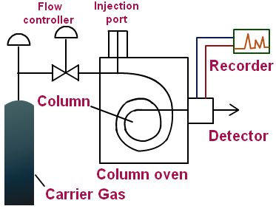
Figure 1: Schematic of a gas chromatogram

Curabitur consequat purus neque, euismod ultrices eros rhoncus vel. Etiam eget hendrerit velit. Pellentesque habitant morbi tristique senectus et netus et malesuada fames ac turpis egestas. Donec interdum arcu eget magna imperdiet, vitae porttitor turpis suscipit. Phasellus ut facilisis augue, id cursus nunc. Sed convallis sapien at auctor finibus. Curabitur lacinia massa convallis, viverra erat a, dictum nisl (Figure 2). Mauris sed ex sit amet diam aliquam aliquam in a sem. Ut cursus, nisi vehicula sollicitudin egestas, magna eros dignissim augue, sed aliquam dolor arcu at neque. Integer rutrum vitae diam nec eleifend. Phasellus ultricies tincidunt nisi, at efficitur lorem vestibulum et. Nunc vel metus condimentum, imperdiet risus at, pretium velit. Sed congue, lectus nec efficitur ultricies, lectus dui congue metus, eleifend lobortis mauris ex non erat. Sed iaculis dolor id euismod feugiat.

Aliquam eleifend lectus sapien, pulvinar sagittis tellus vestibulum sit amet. Nunc condimentum auctor metus id auctor. Nam ipsum lectus, fringilla id elementum in, gravida vitae neque. Nam quis auctor orci. Vivamus mattis velit ut velit tincidunt, at ullamcorper odio cursus. Proin at nisi orci. Aenean tincidunt dolor in ipsum rutrum finibus. Quisque malesuada nisl sit amet dolor commodo condimentum. Donec tempor nisl sed nulla molestie, eget sollicitudin magna feugiat. Nunc at blandit libero, vitae porta leo.

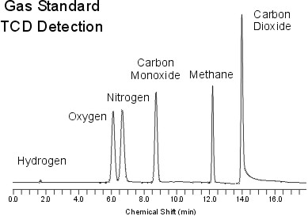
Figure 2: Example of a GC spectrum
Mass Spectrometry
Lorem ipsum dolor sit amet, consectetur adipiscing elit. Nam sit amet sollicitudin turpis. In dictum orci enim. Donec placerat sapien nec nisl pharetra, at vehicula odio efficitur. Phasellus mauris arcu, sagittis interdum lacus sed, varius fringilla nunc. Ut hendrerit tincidunt turpis ac ultrices. Nam diam ex, vulputate sit amet elit at, porta pharetra sem. Vestibulum consequat tempus velit vel scelerisque. Aenean sit amet turpis in tortor aliquam fermentum. Pellentesque pulvinar malesuada venenatis. Cras lacinia ante quis est iaculis, nec scelerisque nulla scelerisque. Duis ut odio sodales, tempor dui eu, dapibus risus (Figure 3).
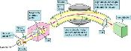
Figure 3: Schematic of a mass spectrometer

Suspendisse potenti. Donec condimentum condimentum tellus, eget euismod eros cursus eu…

- Suspendisse fermentum ut enim eu tempus. Curabitur non ullamcorper lacus, eget faucibus diam. Vestibulum mollis tempor elit a luctus.
- Mauris molestie, neque sit amet suscipit vehicula, dolor nisi mattis augue, in ullamcorper nulla lacus a ante. Aliquam cursus viverra orci, ac tempus est dapibus id.
- Nullam tempor fermentum arcu non venenatis. Nullam commodo feugiat ipsum at luctus. Sed vehicula euismod magna tempor aliquet.

Detecting steroids using GC-MS
Suspendisse potenti. Donec condimentum condimentum tellus, eget euismod eros cursus eu. Suspendisse fermentum ut enim eu tempus. Curabitur non ullamcorper lacus, eget faucibus diam. Vestibulum mollis tempor elit a luctus. Mauris molestie, neque sit amet suscipit vehicula, dolor nisi mattis augue, in ullamcorper nulla lacus a ante. Aliquam cursus viverra orci, ac tempus est dapibus id. Nullam tempor fermentum arcu non venenatis. Nullam commodo feugiat ipsum at luctus. Sed vehicula euismod magna tempor aliquet. Proin vel volutpat quam. Nam dapibus pellentesque arcu, et tempor justo ullamcorper nec (see Figure 4).

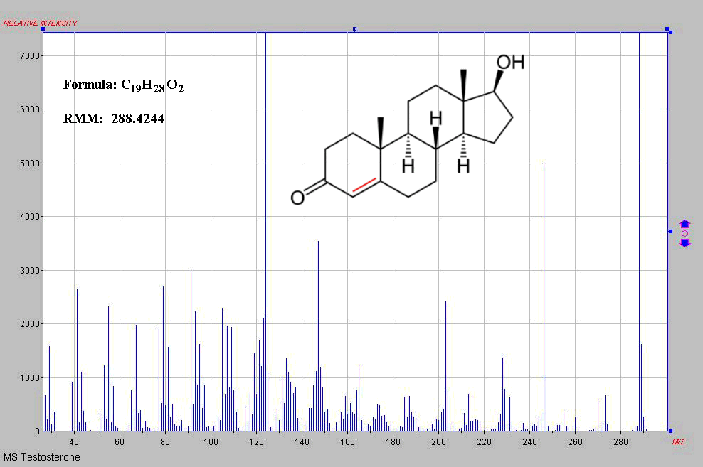
Figure 4: Chemical structure and mass spectrum of testosterone

Add more information about how to reference things
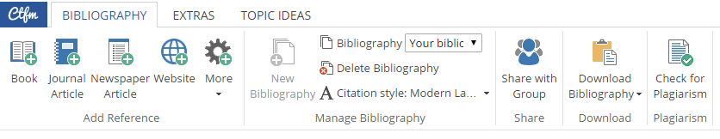

Type of source | Book | Web article (no date)
Example | Your chemistry textbook | http://www.scientific.org/tutorials/articles/gcms.html
What to enter on www.citethisforme.com | 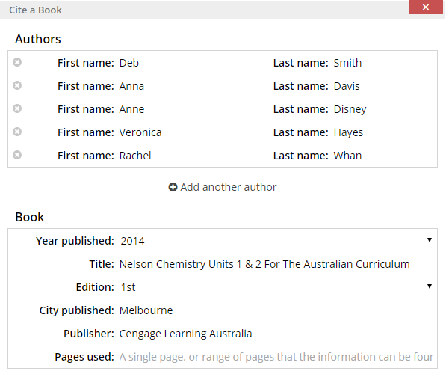 | 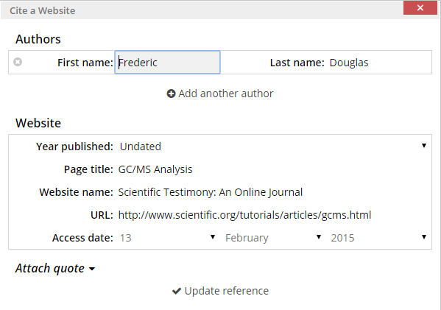
What the in-line reference will look like | (Smith et al., 2014) | (Douglas, n.d.)
What the formatted reference will look like  (this goes at the end in your reference list) | Smith, D., Davis, A., Disney, A., Hayes, V. and Whan, R. (2014). Nelson Chemistry Units 1 & 2 For The Australian Curriculum. Melbourne: Cengage Learning Australia. | Douglas, F. (n.d.). GC/MS Analysis. [online] Scientific Testimony: An Online Journal. Available at: http://www.scientific.org/tutorials/articles/gcms.html [Accessed 13 Feb. 2015].
Citing references with www.citethisforme.com

Example references list (sorted in alphabetical order):
Douglas, F. (n.d.). GC/MS Analysis. [online] Scientific Testimony: An Online Journal. Available at: http://www.scientific.org/tutorials/articles/gcms.html [Accessed 13 Feb. 2015].
Sanker, E. and Allen, J. (2015). What is a calibration curve?. [online] wiseGEEK. Available at: http://www.wisegeek.com/what-is-a-calibration-curve.htm# [Accessed 13 Feb. 2015].
Smith, D., Davis, A., Disney, A., Hayes, V. and Whan, R. (2014). Nelson Chemistry Units 1 & 2 For The Australian Curriculum. Melbourne: Cengage Learning Australia.
TutorVista, (2015). Spectroscopy. [online] Available at: http://chemistry.tutorvista.com/analytical-chemistry/spectroscopy.html [Accessed 13 Feb. 2015].

Chemistry Unit 1 & 2 – Assignment #1 Marking Key
Aspect | 0 marks | 1 mark | 2 marks | 3 marks
Introduction and conclusion | No introduction / conclusion | - Introduction: Defines topic, outlines main points  - Conclusion: Summarises main points
Description of application | Lists the chosen application | Explains the importance of the chosen application. | Explains the importance of the chosen application and describes the chemistry of the substances which need to be analysed.
How the instrument works | Describes a general principle of how machine works but lacks many details | A diagram shows the parts of the instrument and some information is given about what the different parts of the instrument do. | A diagram shows the function of the machine and information is given about the role of different parts of the instrument. Some description of chemical principles underpinning how the machine works using appropriate terminology (e.g. emission and absorption for AAS, elution and retention for GC-MS) | The function of each part is clearly described with details that show a level of research (i.e. not just paraphrased from textbook). Gives elaborate background into the chemical principles relevant to the analytical method (e.g. energy levels and absorption spectra for AAS, chromatographic principles for GC, etc.)
How data from the instrument is used | No explanation of how the output from the machine is used | Describes the type of output generated by the instrument. | Describes how the output of the instrument can be used to analyse, identify or detect substances and includes an appropriate image/table. | Explains how the results are used to analyse, identify or detect substances. Includes example AAS data or GC-MS data and demonstrates how this would be used for the particular application described.
References list | Does not meet the criteria for 1 mark | The references list shows references using an appropriate referencing system such as Harvard or Chicago. Minimal mistakes are made in referencing (e.g. missing author names, wrong dates)
In-line citations | Does not meet the criteria for 1 mark | All information that is not common knowledge is attributed using a form of in-line citations.
Sources | Does not meet the criteria for 1 mark | At least three sources are used including at least one text source. | SHORT ANSWER MARK = ____ / 10
Conventions for figures and tables | Does not include figures/tables with correct conventions | Includes at least one figure or table. All figures and tables are labelled, include captions and sources, and a referenced in the main text. | EXTENDED RESPONSE MARK = ____ / 14
Writing | Spelling/grammatical errors, poor communication of ideas | Minimal spelling/grammatical errors. Writing flows in a logical order. | TOTAL = ____ / 24

